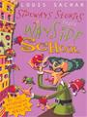
Sideways Stories from Wayside School
Louis Sachar

Humorous episodes take place in the classroom on the thirtieth floor of Wayside School, which was accidentally built sideways with one classroom on each story.

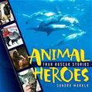
Animal Heroes: True Rescue Stories
Sandra Markle

This book consists of real-life stories about animal heroes. It also discusses how people have learned to work with animals in ways that make the most of each animal's special abilities to help humans.

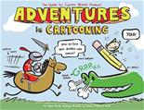
Adventures in Cartooning
James Sturm

This book uses a story about a magical elf who helps a princess learn how to draw a comic to present techniques for and advice about drawing comics.

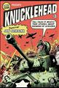
Knucklehead: Tall Tales & Mostly True Stories About Growing Up Scieszka
Jon Scieszka

Part memoir, part scrapbook, this trip down memory lane provides a unique glimpse into the formation of a creative mind and a free spirit.

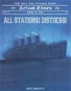
All Stations! Distress! April 15, 1912: The Day the Titanic Sank Don Brown

This book presents an account of the deadly voyage of the "Titanic" in April 1912, when about 2,200 passengers and crew, rich and poor alike, fought to survive.

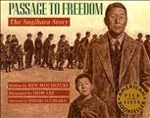
Passage to Freedom: The Sughihara Story
Ken Mochizuki

The story of one man's courage and the respect between father and son who shared the weight of an amazing act of humanity during World War II.

School or Public Library facts and information here.

Your School or Public Library Name Here

Readers Choice Award
2012 Nominees
Grades 3-5

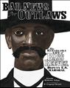
Bad News for Outlaws: The Remarkable Life of Bass Reeves, Deputy U.S. Marshal
Vaunda Micheaux Nelson

This biography profiles the life of Bass Reeves, a former slave who was recruited as a deputy United States Marshal in the area that was to become Oklahoma.

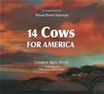
14 Cows for America
Carmen Deedy

This book presents an illustrated tale of a gift of fourteen cows given by the Maasai people of Kenya to the U.S. as a gesture of comfort and friendship in the wake of the attacks of September 11, 2001. The coauthor is Wilson Kimeli Naiyomah.

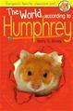
World According to Humphrey
Betty Birney

Humphrey, pet hamster at Longfellow School, learns that he has an important role to play in helping the teacher and his classmates.

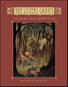
Sisters Grimm: The Fairy-Tale Detectives
Michael Buckley

Orphans Sabrina and Daphne Grimm are sent to live with an eccentric grandmother who they have always believed to be dead.

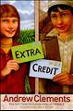
Extra Credit
Andrew Clements

As letters flow back and forth, between the prairies of Illinois and the mountains of Afghanistan, across cultural and religious divides, sixth-grader Abby, ten-year-old Amira, and eleven-year-old Sadeed begin to speak and listen to each other.

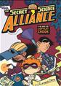
Secret Science Alliance and the Copycat Crook
Eleanor Davis

Eleven-year-old Julian thought changing schools would mean leaving his "nerdy" persona behind, but instead he forms an alliance with fellow inventors Greta and Ben and works to prevent an adult from using one of their gadgets for nefarious purposes.

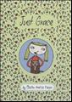
Just Grace
Charise Harper

Misnamed by her teacher, seven-year-old Just Grace prides herself on being empathetic, but when she tries to help a neighbor feel better, her good intentions backfire.

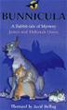
Bunnicula: A Rabbit Tale of Mystery
Deborah and James Howe

Chester, the Monroe family's cat, resorts to hilarious antics to alert his owners and Harold, their dog, that the newly adopted bunny may actually be a vegetable vampire. The coauthor is James Howe.

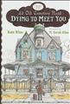
Dying to Meet You
Kate Klise

In this story told mostly through letters, children's book author I.B. Grumply gets more than he bargained for when he rents a quiet place to write for the summer.

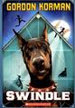
Swindle
Gordon Korman

After unscrupulous collector S. Wendell Palomino cons sixth-grader Griffin Bing out of a valuable baseball card, Griffin puts together a band of misfits to break into Palomino's heavily guarded store and steal the card back.

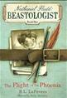
Flight of the Phoenix
R. L. LaFevers

With his parents lost at sea, Nate lands on the doorstep of a distant cousin, the world's last remaining beastologist. Soon he is whisked off on his first expedition, to Arabia, where the world's only phoenix prepares to lay its new egg.

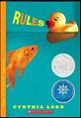
Rules
Cynthia Lord

Frustrated at life with an autistic brother, twelve-year-old Catherine longs for a normal existence, but her world is further complicated by a friendship with a young paraplegic.

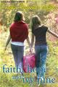
Faith, Hope and Ivy June
Phyllis Naylor

During a student exchange program, seventh-graders Ivy June and Catherine share their lives, homes, and communities and find that although their lifestyles are total opposites, they have a lot in common.

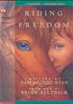
Riding Freedom
Pam Munoz Ryan

Charlotte (Charley) Parkhurst runs away from an orphanage, poses as a boy, moves to California, and fools everyone by her appearance.

