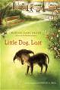Little Dog, Lost

Marion Dane Bauer

R.L. 4.4 Pts. 2

A boy, a dog, and an old man are lonely before the boy plans a rally, the dog looks for a boy, and all the townspeople run to the old man's aid when lightning strikes his home and something miraculous happens.

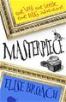Masterpiece

Elise Broach

R.L. 4.8 Pts. 8

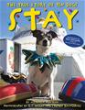After Marvin, a beetle, makes a miniature drawing as an eleventh birthday gift for James, a human with whom he shares a house, the two new friends work together to help recover a Dürer drawing stolen from the Metropolitan Museum of Art.

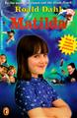Matilda

Roald Dahl

R.L. 5.0 Pts. 6

Matilda applies her untapped mental powers to rid the school of the evil, child-hating headmistress, Miss Trunchbull, and to restore her nice teacher, Miss Honey, to financial security.

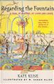Regarding the Fountain

Kate Klise

R.L. 5.8 Pts. 2

When the principal asks a fifth grader to write a letter regarding the purchase of a new drinking fountain for their school, he finds that all sorts of chaos results.

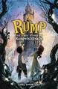Rump

Liesl Shurtliff

R.L. 4.4 Pts. 9

This story relates the tale of Rumpelstiltskin's childhood and youth, explaining why his name is so important, how he is able to spin straw into gold, and why a firstborn child is his reward for helping the miller's daughter-turned-queen.

Sidekicks

Dan Santat

R.L. 2.3 Pts. 1

When Captain Amazing feels he is getting too old to be a reliable superhero, he tries to hire a new sidekick, but his pets have different ideas.

Stay

Michaela Muntean

R.L. 4.6 Pts. 0.5

Luciano Anastasini, a man who calls the circus home, and ten homeless dogs are brought together by fate.

Bluestem Award Nominees are shelved near the library door. They each have the Bluestem emblem on the front cover. Read at least four by the end of February, 2016, to be able to participate in the statewide voting. The more you read, the better your vote will be. Read all 20 and receive a special award at the end of the year. 

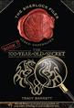



This was created by Roberta Meyer at St. Anthony’s Grade School. Feel free to modify it for your own school.



Readers Choice Award

2016 Nominees

Grades 3-5

The 100-Year-Old Secret

Tracy Barrett

R.L. 4.4 Pts. 4

Xena and Xander Holmes, an American brother and sister living in London for a year, discover when they are inducted into the Society for the Preservation of Famous Detectives that Sherlock Holmes was their great-great-great-grandfather.

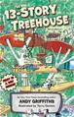The 13-Story Treehouse

Andy Griffiths

R.L. 3.8 Pts. 1

In a treehouse with a bowling alley and a lemonade fountain, Andy and Terry are too busy with flying cats and sea-monkey mishaps to work on their next book.

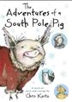The Adventures of a South Pole Pig

Chris Kurtz

R.L. 4.6 Pts. 6

The day Flora spots a team of sled dogs is the day she sets her heart on becoming a sled pig. Before she knows it, she's on board a ship to Antarctica for the most exhilarating and dangerous adventure of her life.

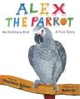Alex, the Parrot

Stephanie Spinner

R.L. 4.1 Pts. 0.5

This true story of an African grey parrot named Alex explains how his intelligence changed the way scientists view the brain.

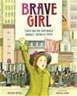Brave Girl

Michelle Markel

R.L. 5.0 Pts. 0.5

This illustrated account of Clara Lemlich's role in the influential 1909 women laborer's strike depicts how she worked grueling hours to acquire an education and support her family before organizing a massive walkout to protest unfair working conditions.

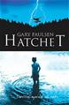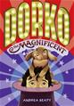Dorko the Magnificent

Andrea Beaty

R.L. 4.7 Pts. 5

Robbie Darko is an old-school, pull-a-rabbit-out-of-your-hat-style magician, but despite his best efforts, something always goes wrong with his tricks until crotchety Grandma Melvyn moves in and teaches him something about the true meaning of magic.

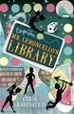Escape from Mr. Lemoncello’s Library

Chris Grabenstein

R.L. 4.5 Pts. 7

Twelve-year-old Kyle gets to stay overnight in the new town library, designed by his hero, the famous gamemaker Luigi Lemoncello, with other students but finds he must work with friends to solve puzzles in order to escape.

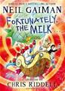Fortunately, the Milk

Neil Gaiman

R.L. 4.3 Pts. 1

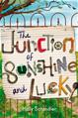While picking up milk for his children's cereal, a father is abducted by aliens and finds himself on a wild adventure through time and space.

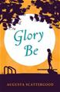Glory Be

Augusta Scattergood

R.L. 4.3 Pts. 5

Glory faces her twelfth birthday in 1964 and struggles with the changes she sees happening around her when she witnesses tempers rise in a debate over a segregated public pool.

Hatchet

Gary Paulsen

R.L. 5.7 Pts. 7

After a plane crash, thirteen-year-old Brian spends 54 days in the wilderness, learning to survive initially with only the aid of a hatchet given to him by his mother, and learning also to survive his parents' divorce.

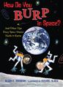How Do You Burp in Space?

Susan E. Goodman

R.L. 5.4 Pts. 1

This nonfiction travel guide to space tourism includes information about accommodations, attractions, and more.

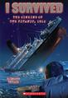I Survived: the Sinking of the *Titanic*, 1912

Lauren Tarshis

R.L. 3.9 Pts. 1

Ten-year-old George Calder's life changes forever as he, his little sister, Phoebe, and Aunt Daisy set out across the ocean on the *Titanic* in 1912.

The Junction of Sunshine and Lucky

Holly Schindler

R.L. 5.6 Pts. 7

Auggie and her grandfather use found objects to transform the appearance of their home and, in the process, change a whole town's perceptions of beauty and art.