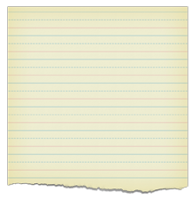
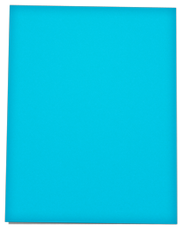

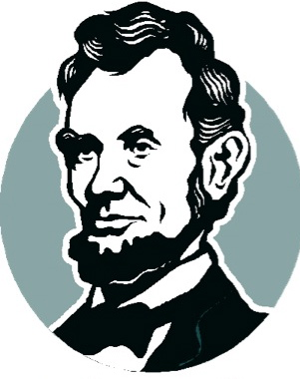


2015 Abraham Lincoln H.S. Book Award

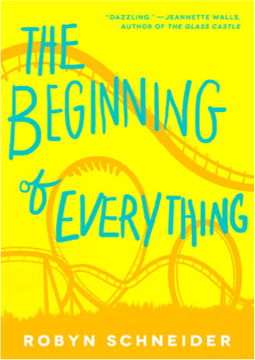 | The Beginning of Everything by Robyn Schneider  Star athelete and prom king Ezra Faulkner's life is irreparably transformed by a tragic accident and the arrival of eccentric new girl Cassidy Thorpe.  (RL= 6.1)
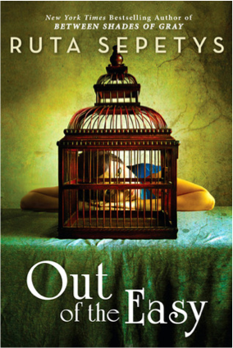 | Out of the Easy by Ruta Sepetys  Josie, the seventeen-year-old daughter of a French Quarter prostitute, is striving to escape 1950 New Orleans and enroll at prestigious Smith College when she becomes entangled in a murder investigation.
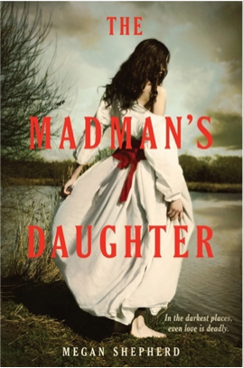 | The Madman’s Daughter by Megan Shepherd This novel tells the story of Dr. Moreau's daughter Juliet, who travels to her estranged father's island only to encounter murder, madness, and a scintillating love triangle. (RL=4.6)
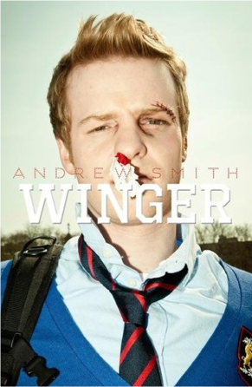 | Winger by Andrew Smith  Through humor, doodling, and rugby, Ryan Dean navigates life with his boarding school’s troublemakers - maybe Annie, his crush, can help? (RL=5.3)
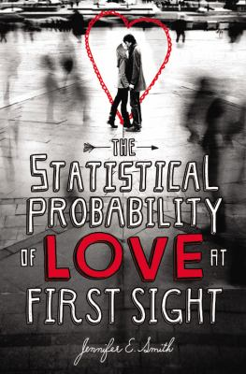 | The Statistical Probability of Love at First Sight by Jennifer E. Smith  Hadley and Oliver fall in love on the flight from New York to London, but after a cinematic kiss they lose track of each other at the airport until fate brings them back together on a very momentous day. (RL= 6.1)
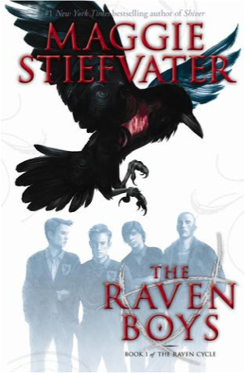 | The Raven Boys by Maggie Stiefvater  Though she is from a family of clairvoyants, Blue Sargent's only gift seems to be that she makes other people's talents stronger, and when she meets Gansey, one of the Raven Boys from the expensive Aglionby Academy, she discovers that he has talents of his own--and that together their talents are a dangerous mix. (RL= 5.4)

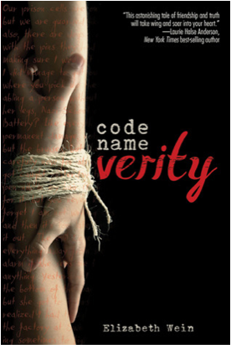 | Code Name Verity by Elizabeth Wein  In 1943, a British fighter plane crashes in Nazi-occupied France and the survivor tells a tale of friendship, war, espionage, and great courage as she relates what she must to survive while keeping secret all that she can. (RL= 6.5)
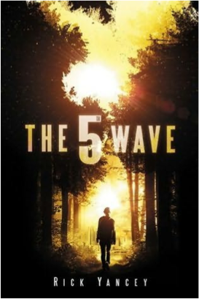 | The 5th Wave by Rick Yancey  Cassie Sullivan, the survivor of an alien invasion, must rescue her young brother from the enemy with help from a boy who may be one of them (RL= 4.6)
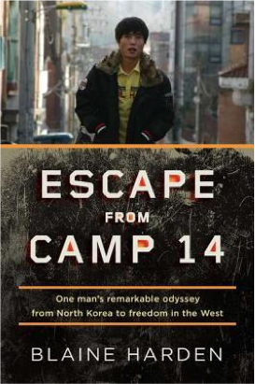 | Escape from Camp 14 by Blaine Harden  Chronicles the life of Dong-hyuk Shin, who was raised in a political prison camp in North Korea, and describes the inhuman conditions inside, his harrowing escape from the camp and the country, and his efforts to raise awareness of the camps to others. (RL= 8.1)
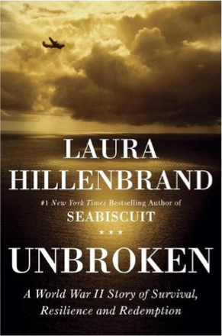 | Unbroken by Laura Hillenbrand  A biography of Olympic runner and World War II bombardier, Louis Zamperini, who had been rambunctious in childhood before succeeding in track and eventually serving in the military, which led to a trial in which he was forced to find a way to survive in the open ocean after being shot down.(RL=7.7)

2015 ABE Awards

Reading Rocks!!!




What is the ABE Award?

The Abraham Lincoln High School Book Award (known as the "ABE AWARD") is given each year to an author whose book is voted Most Outstanding by participating Illinois high school students. The award is sponsored by the Illinois School Library Media Association (ISLMA).

How Can I Participate?

Read a minimum of 4 ABE-nominated books prior to the final voting in March 2014. Copies of each book are available in the RHS Library. For each book you read, fill out the ABE FORM and return it to the library. This form will enter you in a drawing to receive great prizes. In March, you can vote for your favorite and help decide the winner!

ABE Readers of the Week!

- Read an ABE book
- Fill out an ABE Book Review form
- Return the form to the library and be entered into a drawing to win a $5 gift certificate to Jimmy Johns or a Free Large pizza from Vince’s Restaurant
- Every Friday, two ABE formswill be pulled and these student will win FREE food! The more books you read, the more chances you have to win.

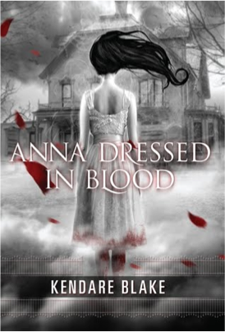 | Anna Dressed in Blood by Kendare Blake  Cas kills dead people.He’s after Anna next, a ghost who kills everyone in her path. (RL= 4.6)
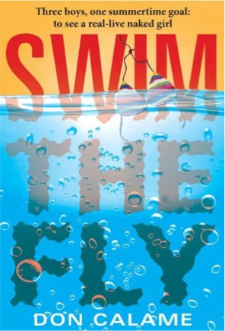 | Swim the Fly by Don Calame  Swim team members and best friends Matt, Sean, and Coop, set themselves the summertime goal of seeing a live girl naked, and while the chances of that happening seem very dim, Matt's personal goal to swim the one-hundred-yard butterfly to impress the new girl on the team seems even less likely to happen. (RL= 3.8)
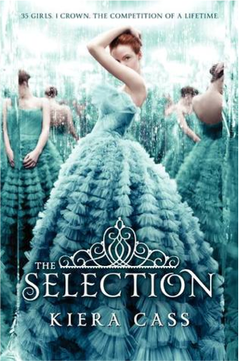 | The Selection by Kiera Cass  Sixteen-year-old America Singer is living in the caste-divided nation of Illea, which formed after the war that destroyed the United States. America is chosen to compete in the Selection--a contest to see which girl can win the heart of Illea's prince--but all she really wants is a chance for a future with her secret love, Aspen, who is a caste below her (RL= 4.7)
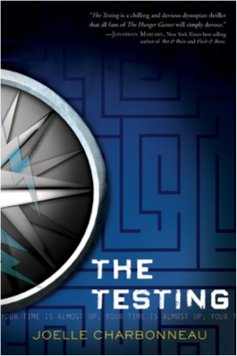 | The Testing by Joelle Charbonneau  Sixteen-year-old Malencia (Cia) Vale is chosen to participate in The Testing to attend the University; however, Cia is fearful when she figures out that her friends who do not pass The Testing are disappearing. (RL= 5.6)
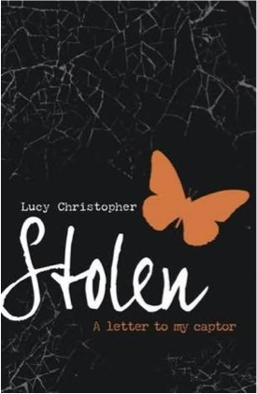 | Stolen by Lucy Christopher  He stole her away, and now she’s trapped.  Why does she think she loves him? (RL=4.3)
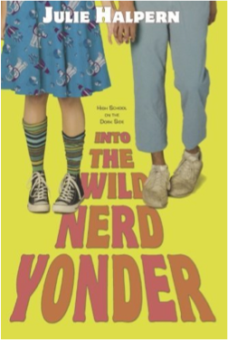 | Into the Wild Nerd Yonder by Julie Halpern  When high school sophomore Jessie's long-term best friend transforms herself into a punk and goes after Jessie's would-be boyfriend, Jessie decides to visit "the wild nerd yonder" and seek true friends among classmates who play Dungeons and Dragons. (RL=5.4)

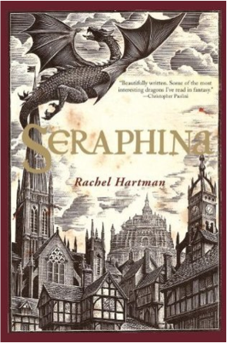 | Seraphina by Rachel Hartman  In a world where dragons and humans coexist in an uneasy truce and dragons can assume human form, Seraphina, whose mother died giving birth to her, grapples with her own identity amid magical secrets and royal scandals, while she struggles to accept and develop her extraordinary musical talents. (RL= 6.0)
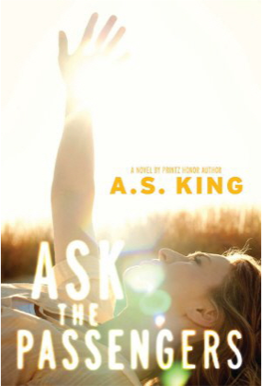 | Ask the Passengers by A.S. King  Astrid has one big secret, and so many questions. Her family and small town don’t accept her love. How will they react to her news? (RL= 3.9)
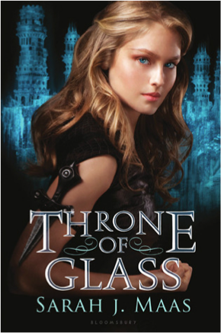 | Throne of Glass by Sarah J. Maas  Celaena is known as the best assassin - and now the king wants her. She must fight to prove her worth and earn her freedom. (RL=5.7)
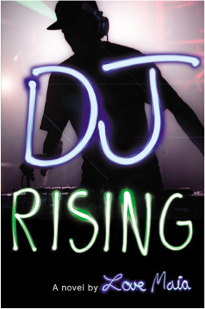 | DJ Rising by Love Maia  Sixteen-year-old Marley Diego-Dylan's career as "DJ Ice" is skyrocketing, but his mother's heroin addiction keeps dragging him back to earth.  (RL= 5.3)
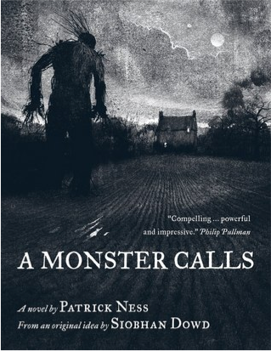 | A Monster Calls by Patrick Ness  Conor is haunted. The monster comes to his bedroom at midnight. And the monster wants him. (RL= 4.8)
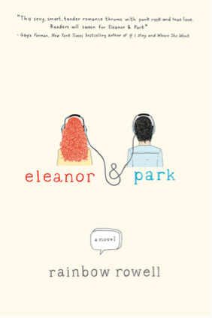 | Eleanor & Park by Rainbow Rowell  Set over the course of one school year in 1986, this is the story of two star-crossed misfits--smart enough to know that first love almost never lasts, but brave and desperate enough to try. (RL= 3.8)

